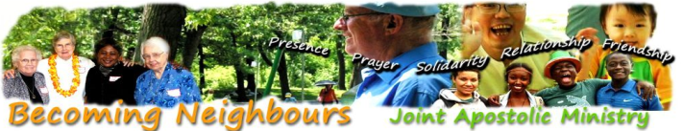

GATHERING SONG: “All Are Welcome” (Gather pg. 846)

World Refugee Day June 20, 2012

"What one step will you take on behalf of refugees?"

United Nations' World Refugee Day honours the courage, strength and determination of women, men and children forced to flee their homeland under threat of persecution, conflict and violence.

The number of forcibly displaced people around the world has reached a 15-year high with the vast majority languishing in poor countries ill-equipped to cater to their needs. At the end of last year it was estimated that there were 43.7 million refugees and people displaced within their country by events such as war and natural disasters. More than half of the total are children. The figure does not take into account the new wave of migration and displacement set in train by the upheaval of the Arab Spring.

World Refugee Day is an opportunity to honour the spirit and courage of millions of refugees worldwide. It is a Day to recognize the contributions of refugees in our communities and an invitation for each of us to take one step on behalf of refugees.

OPENING PRAYER

Beloved God, we are Your children longing for You. We yearn to know You, to be with You, to reunite ourselves in You. As Father of a crucified son, You hold in Your heart the anguish of knowing that loved ones suffer. You experience the agony of all people who long to be with those they love but especially of refugee families separated by war and violence who daily carry a heavy cross of pain and loss.

Bind us together. Strengthen our efforts to reunite all human families whether separated by small conflicts among themselves or by world tragedies. Bring mothers, fathers, children, grandparents, brothers and sisters back to each other and back to You. Unite us to one another as neighbour. In the spirit of Jesus, we pray: Amen.

SCRIPTURE: Luke 24:15, 30

“As the travellers to Emmaus walked, “Jesus himself came up and walked beside them, but they did not recognize him.” The travellers invited Jesus to stay with them, and “while He was with them at the table, he took the bread and blessed it; then He broke it and handed it to them. And their eyes were opened and they recognized him . . .”
(Catherine and Steve re-united with their daughter, Patricia)

READING: Cesar Chavez

“What do we want the church to do? We ask for its presence with us, beside us, as Christ among us. We ask the church to sacrifice with the people for social change, for justice and for love of brother and sister. We don’t ask for words. We ask for deeds. We don’t ask for paternalism. We ask for servanthood . . .”
ONE STEP TO TAKE:

OFFER TO BE A COMPANION
with Becoming Neighbours.

VIEW U.N. VIDEO
ANGELINA JOLIE
“Asks us to do 1 thing”
www.youtube.com/watch?v=v5Z4SmRiaX0&list=UUXXD082fQGZ-1EI22YhRm-w&index=7&feature=plcp

PRAY FOR ONE REFUGEE
whom you have met.

VIEW AND REFLECT
www.jrsusa.org/publications_voice.php

VIEW THE EDUCATIONAL FILM
"6 Voices for 6 Decades" Intimate portrait of six compelling refugee stories spanning six decades.
www.youtube.com/watch?v=Pk34s6GOZ7Y

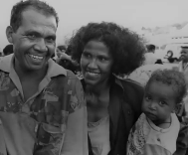

ATTEND THE EVENT
Public Event Yonge/Dundas 4:00pm – 8:00pm June 20
Contact: Rana Khan (UNHCR)
Tel: (416) - 954-1188

VIEW THE CN TOWER
(lit the colour of blue)
to honour UN Aid Workers)

REFLECTION

God invites us to recognize Christ in the travellers on the road. Today, the lives of refugees continue to call out to us and invite us to open our eyes to recognize one another as neighbour.

RECALL A MOMENT OF ENCOUNTER WITH A REFUGEE(S).
How were you neighbour with one another?
What did you learn about yourself?
What is the request God is making of you at this moment?
"What is one step you can/will take on behalf of refugees?"

LITANY FOR REFUGEES

L: Jesus, for those who hunger,
for those who cannot provide for their children,
All: You become bread, you become generosity.
L: Jesus, for those who thirst, for those whose land is parched,
All: You become living water, You become wine at the table.
L: Jesus, for those in need, for those whose lives are in danger,
All: You become aid, You become refuge.
L: Jesus, for those who weep for lost ones,
for those who are lost and frightened,
All: You are the friend, the open door, the comforting arms.

L: ‘Do unto others as I have done for you.’
All: Jesus, with Your grace we will do for others
as You have done for us.

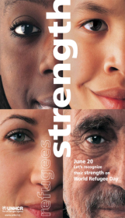
PRAYERS OF PETITION

OUR FATHER

FINAL BLESSING:

May God our Creator be praised as we recognize one another as neighbour; may Christ the Redeemer liberate and lead home all who are lost or in danger; may the Spirit of Life unite us as one planetary family filled with mutual respect and all inclusive love for each other and for our earth. Amen.

Becoming Neighbours 2685 Kingston Road Toronto, ON M1M 1M4 . 416.267.4817 . jam@becomingneighbours.ca

